Software Requirement Specification(SRS) for

Scrap Trading System Portal

# Introduction

### 1.1 Purpose:

This document is meant to delineate the features of Scrap Trading System Portal, so as to serve as a guide to the developers on one hand and software validation document for the prospective client on the other.

It is a system design especially for large, premium and small car rental business. The car rental system provides complete functionality of listing and booking car. In this system, Tourism and Travelling facilities also provide.

### 1.2 Scope:

This system allows the Users to easily Buy or Sell the Scrap whenever they need with use of this system.

### 1.3 Definitions:

STS- Scrap Trading System

SRS- Software Requirement Specification

GUI- Graphical User Interface

**1.5 Overview:**

The Scrap Treading System is a platform through which we will connect scrap dealer/merchants with people who are possessing scrap in house and want to sell it at reasonable price. At this platform we will take description, type, quantity, photos of scrap from seller and put a post on website where other people [buyers/dealer] can explore it and can put bid for it. Then seller will decide who to sell according to various factors like price, pick up time, ease of transport, etc.

**EXISTING SYSTEM**

* An existing system need physically meet to trade Scrap.
* The seller has to go in the merchant’s shop where seller has to show Scrap and then buyer will tell the amount and then they can negotiate accordingly.
* In the existing system seller have to take the scrap to buyer’s shop.

**NEED FOR NEW SYSTEM**

* The new system is totally computerized system.
* A new system provides features like time efficiency to show scrap details, bidding system and whatever the user will give the feedback to the admin.
* This system provides ease in trading the scrap and perfect amount to buy or sell the scrap without much effort in bargaining.
* The bidding can be easily done by user in the system.

**2.Overall Description**:

The main page of the website will contain various available post of scrap to be sold. Through this page anybody who is visiting this website will get to see these posts which will be ordered according to latest uploaded post in ascending manner. Various filters will be provided for sorting all post as buyer’s requirement. Filtering conditions like weight, price, type, material, locations etc. This page will also contain approximate current rates of different types of scrap material. The page will also provide Calculator as feature to the users to make their job easy.

For bidding user (buyer) must login first. If a user is not registered on the website, then they have to register first using register option. After successful login user can bid for scraps. Buyers or users may filter scraps according to various filtering conditions like weight, price, type, material, locations etc.

For uploading post to sell scrap Sellers also have to login first. If a seller is not registered on the website, then they have to register first using register option.

**2.1 Product Functions**:

Scrap Trading System should support this use case:

**Use Case Diagrams** : A Use case is a description of set of sequence of actions. Graphically it is rendered as an ellipse with solid line including only its name. Use case diagram is a behavioral diagram that shows a set of use cases and actors and their relationship. It is an association between the use cases and actors. An actor represents a real-world object. Primary Actor - Sender, Secondary- Actor Receiver.

**Use case diagram for admin**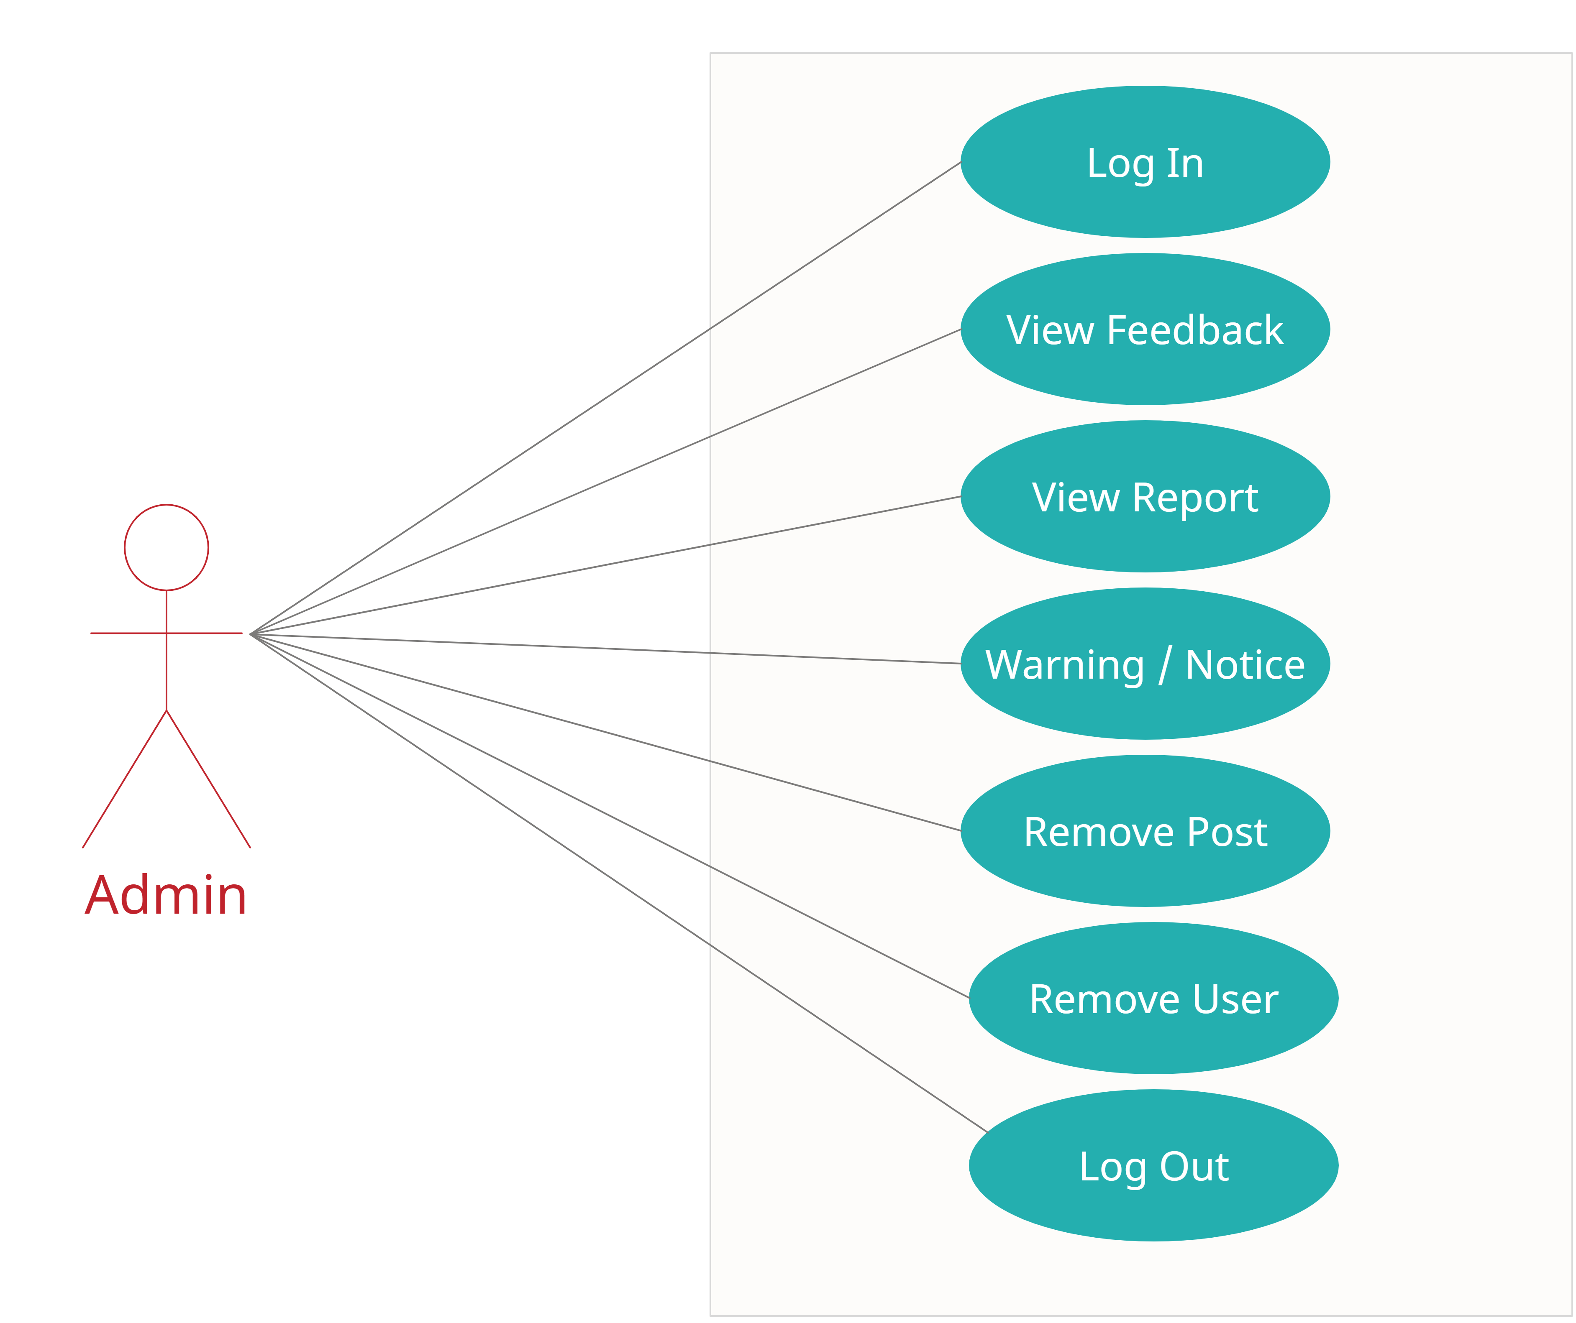

**Use Case diagram for User**

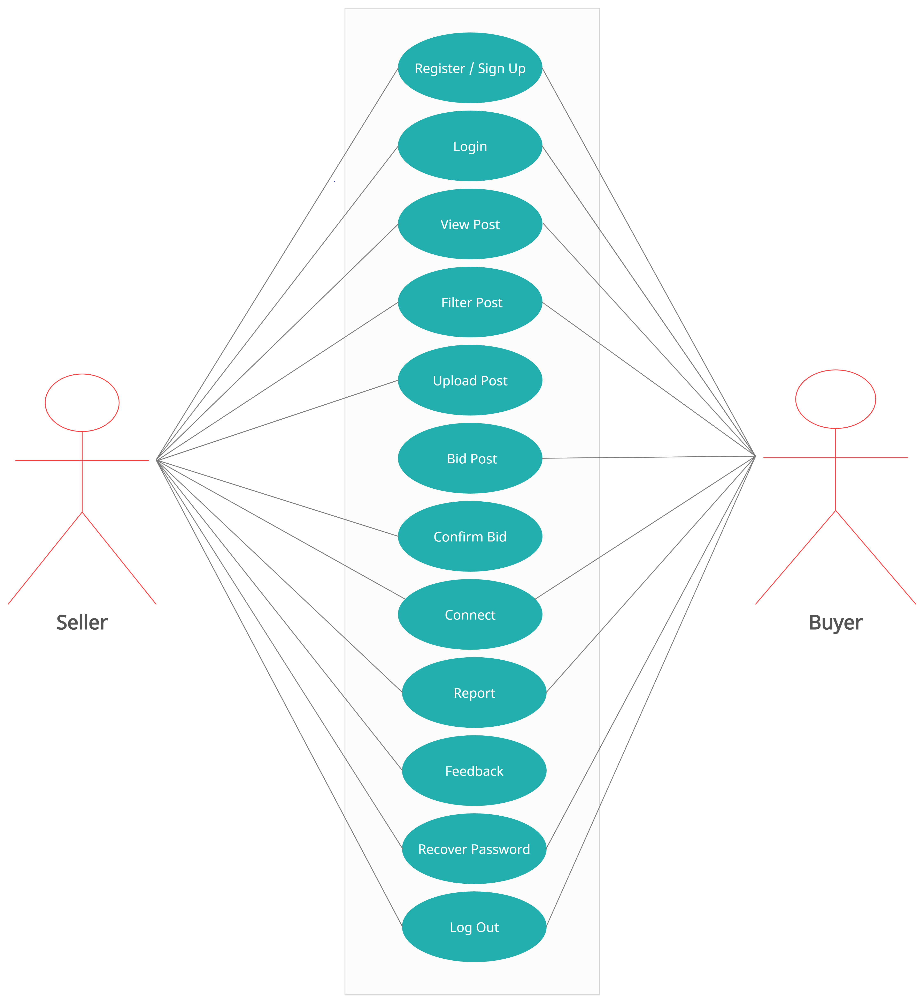

**2.3 User Characteristics**:

User should be familiar with the terms like login, register, bidding etc.

**2.4 Principle Actors**:

2 Principle Actors are Users and Administrator.

**2.5 General Constraints**:

A full internet connection is required for STS.

**2.6 Assumptions and Dependencies**:

Working of STS need Internet Connection.

**3. Specific Requirements**:

3.1 **FUNCTIONAL SPECIFICATION**

User Specification

**Admin:**

Admin can see uploaded post and user’s information. Admin can view feedback and enquiry. If report is received about fraud by any user or complain about any post then admin can warn user or remove them.

**User:**

**1.Seller :**

Seller can post about scrap to be sold, with required information. And select the most suitable bid and connect to that bidder.

**2.Buyer :**

Buyer can see the post of scrap to be sold, bid for desired scrap . If he win the bid then buyer can connect to seller.

**MODULE SPECIFICATION**

**User**

**1.Seller**

**•View Available Posts:**

It is a system design especially for various type of scrap. The user can view Available scrap post .

**•Upload Scrap Posts:**

It is a system design especially for various type of scrap. Upload the scrap post with information.

**•Confirm bid:**

Seller can see top biddings for that post and can select the most suitable bid.

**•Connect:**

Seller can then connect to bidder of selected/winning bid.

**•Give Feedback:**

The Seller will give the feedback to the admin.

**•Report:**

The Report about any fraud can easily do by seller.

**2.Buyer**

**•View Available Posts:**

It is a system design especially for various type of scrap. The buyer can view Available scrap post and Buyer can bid for that post.

**•Bidding for Scrap:**

The Buyer can view Available posts and can bid for desired post.

**•Connect:**

If bidding is get selected of buyer ,then they can connect to seller of that scrap.

**•Give Feedback:**

The buyer will give the feedback to the admin.

**•Report:**

The Report about any fraud can easily do by buyer.

------------------------------------------------------------------------------------

**Admin**

**Dashboard:**

In this section admin can view the overview of the STS (

**Vehicle Brand:**

Admin can create/edit/delete vehicle brands

**Vehicles:**

The Admin can add the car so that The user can see the available cars and book the car.

Admin can also edit and delete the cars.

**Bookings:**

Admin can manage the bookings (confirm and cancel the booking)

**Manage testimonials:**

Admin can manage the testimonials (Active and Inactive the testimonials).

**Manage Contact us query:**

Admin can manage Contact us query.

**View Feedback:**

The admin easily view the feedbacks and solve the query.

**Registered users:**

Admin can view the registered users.

**Manage pages:**

Admin can update the pages data information.

**Contact info:**

Admin can update the contact info.

**Manage Subscribers:**

Admin can manage subscribers.

**3.2 Non-Functional Requirements**:

Following Non-Functional Requirements will be there in the

insurance to the internet:

(i) Secure access to consumer’s confidential data.

(ii) 24X7 availability.

(iii) Better component design to get better performance at peak

time.

(iv) Flexible service based architecture will be highly desirable for

future extension. Non-Functional Requirements define system

properties and constraints.

Various other Non-Functional Requirements are:

➢ Security

➢ Reliability

➢ Maintainability

➢ Portability

➢ Extensibility

➢ Reusability

➢ Compatibility

➢ Resource Utilization

**3.3 Performance Requirements**:

In order to maintain an acceptable speed at maximum number of uploads allowed from a particular customer as any number of users can access to the system at any time. Also the connections to the servers will be based on the attributes of the user like his location and server will be working 24X7 times.

**3.4 Technical Issues**:

This system will work on client-server architecture. It will require an internet server and which will be able to run PHP application. The system should support some commonly used browser such as IE,mozzila firefox,chrome etc.

**HARDWARE REQUIREMENT**

Hardware requirements for insurance on internet

will be same for both parties which are as follows:

|  |  |
| --- | --- |
| **RAM** | 2 GB |
| **Hard disk** | 320 GB |
| **Processor** | Dual Core |

**Software Requirements**

**Client side:**

|  |  |
| --- | --- |
| **Web Browser** | Google Chrome or any  compatible browser |
| **Operating System** | Windows or any equivalent OS |

**Server side:**

|  |  |
| --- | --- |
| **Web Server** | TOMCAT |
| **Server side Language** | ANGULAR |
| **Database Server** | MYSQL |
| **Web Browser** | Google Chrome or any  compatible browser |
| **Operating System** | Windows or any equivalent OS |

**Communication Interfaces**:

The two parties should be connected by LAN or WAN for the communication purpose.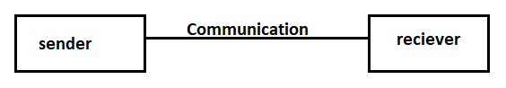

**5.System Design Specification:**

**System Flow Chart**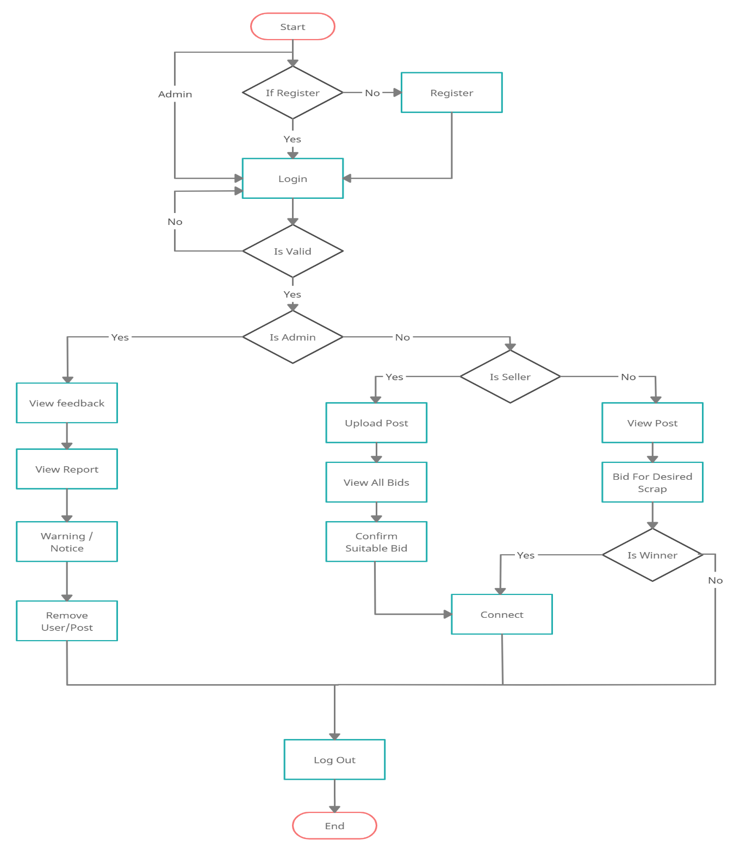

**ER DIAGRAM**

The Entity-Relationship (ER) model was originally proposed by Peter in 1976 [Chen76] as a way to unify the network and relational database views. Simply stated the ER model is a conceptual data model that views the real world as entities and relationships. A basic component of the model is the Entity-Relationship diagram which is used to visually represent data objects. Since Chen wrote his paper the model has been extended and today it is commonly used for database design for the database designer, the utility of the ER model is:

* It maps well to the relational model. The constructs used in the ER model can easily be transformed into relational tables.
* It is simple and easy to understand with a minimum of training. Therefore, the model can be used by the database designer to communicate the design to the end user.
* In addition, the model can be used as a design plan by the database developer to implement a data model in specific database management software.

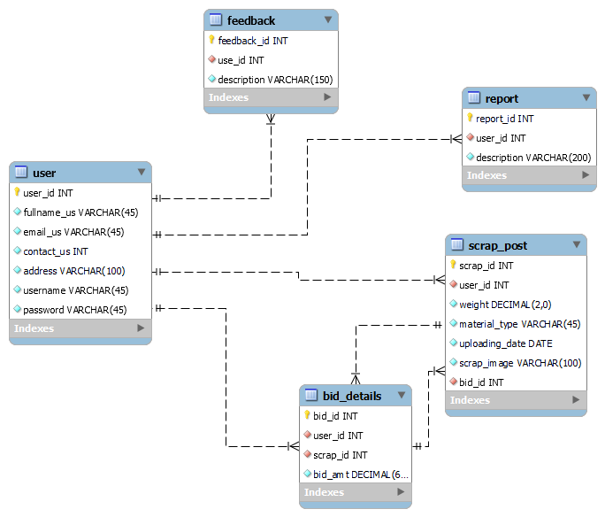

**Activity Diagram for admin**

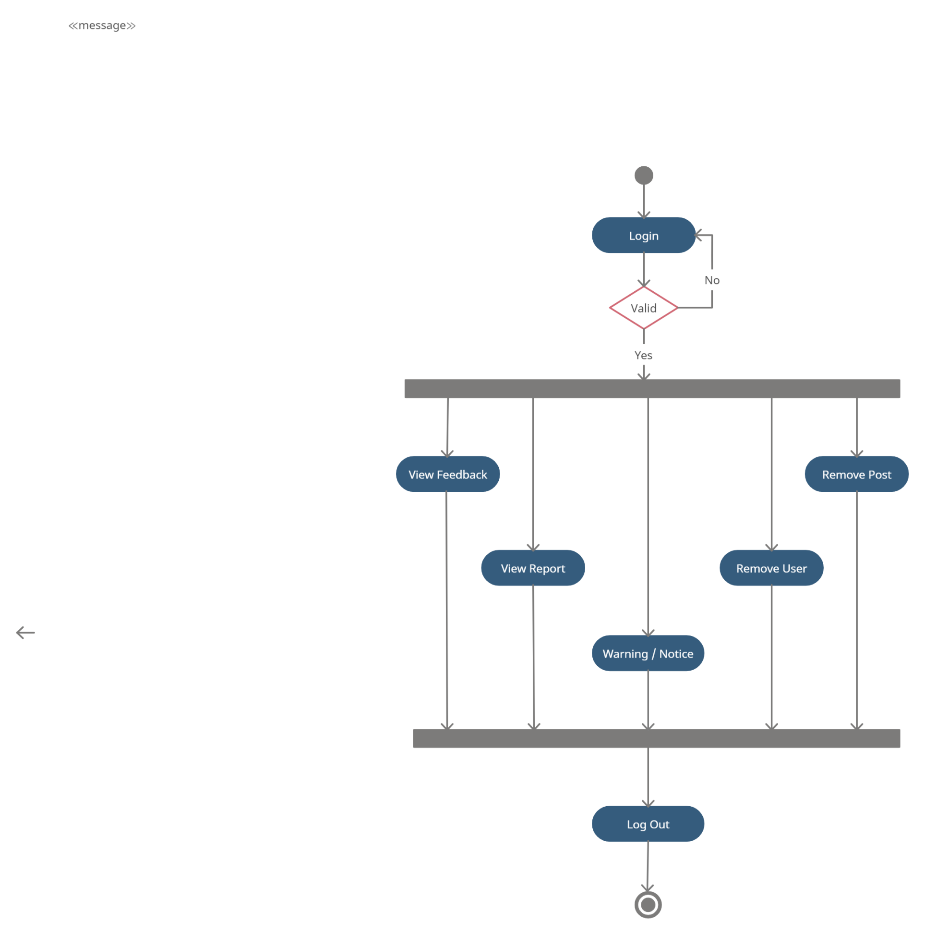

**Activity Diagram for user**

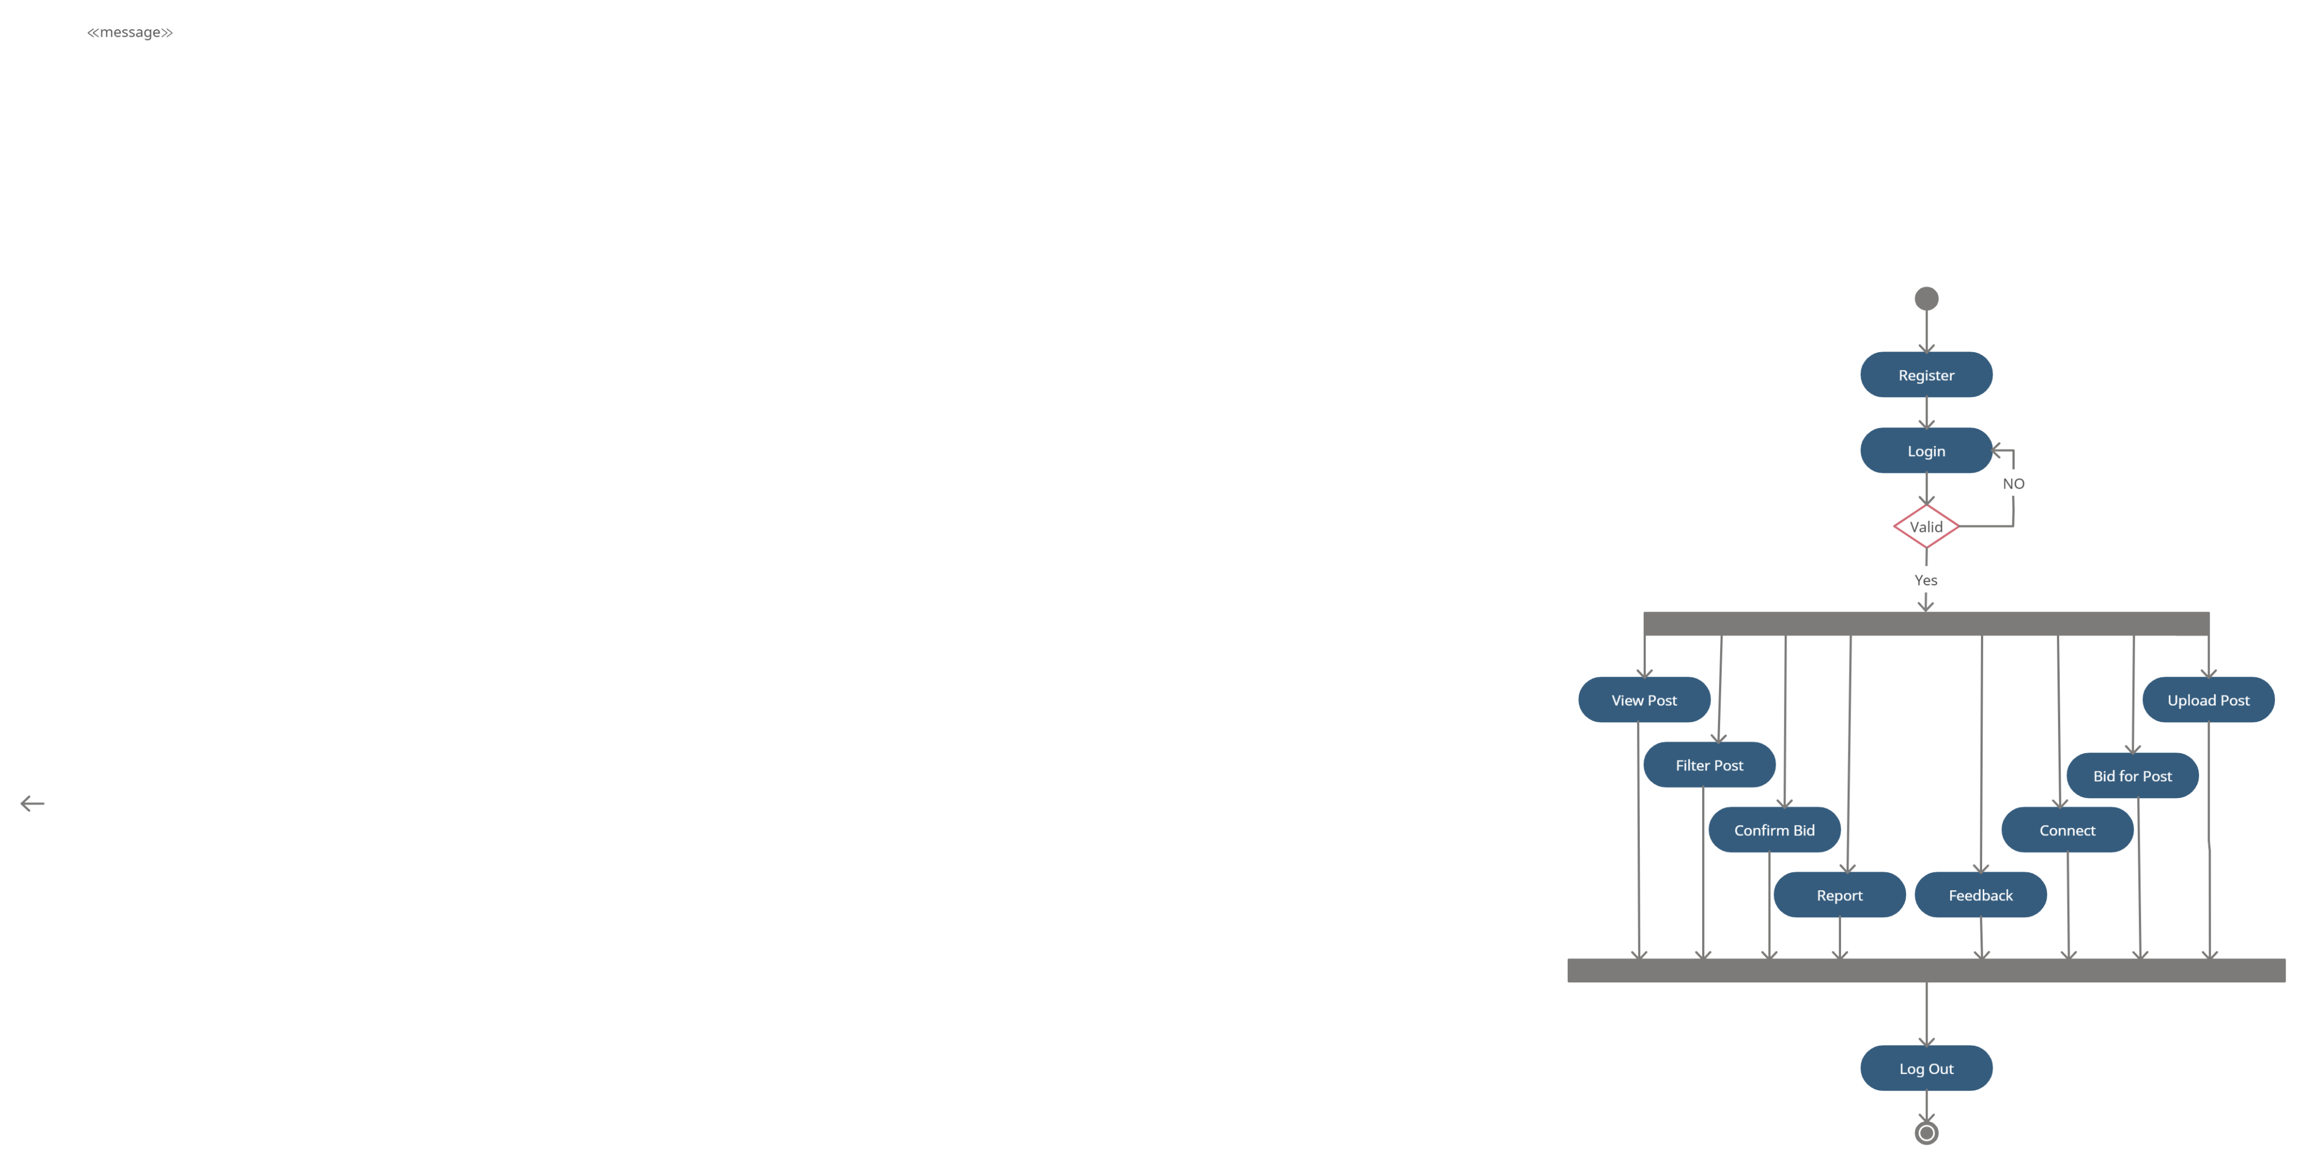

**Sequence Diagram for admin**

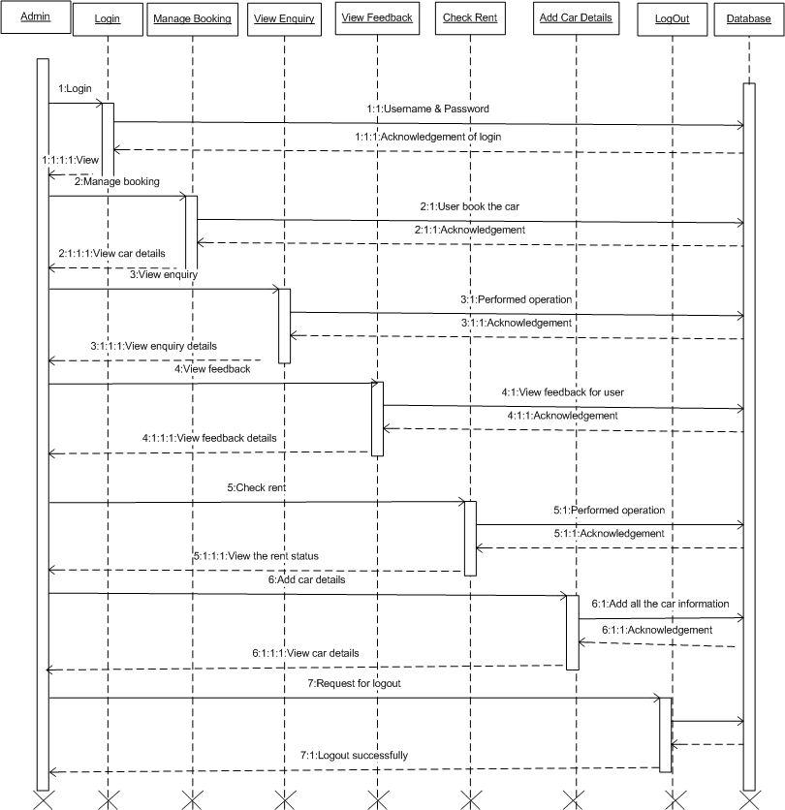

**Sequence Diagram for User**

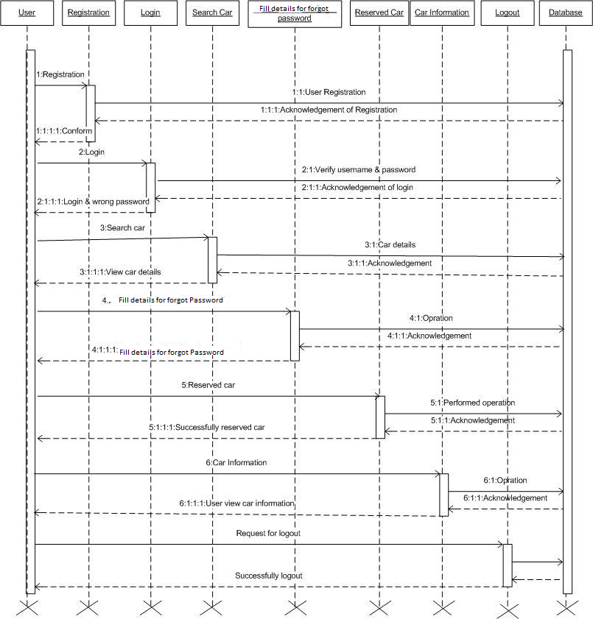

**DATABASE DESIGN**

The data in the system has to be stored and retrieved from database. Designing the database is part of system design. Data elements and data structures to be stored have been identified at analysis stage. They are structured and put together to design the data storage and retrieval system.

A database is a collection of interrelated data stored with minimum redundancy to serve many users quickly and efficiently. The general objective is to make database access easy, quick, inexpensive and flexible for the user. Relationships are established between the data items and unnecessary data items are removed. Normalization is done to get an internal consistency of data and to have minimum redundancy and maximum stability. This ensures minimizing data storage required, minimizing chances of data inconsistencies and optimizing for updates. The MS Access database has been chosen for developing the relevant databases.

**User Registration:**

|  |  |
| --- | --- |
| **Table Name** | user |
|  |  |
| **Description** | This table is provide the information about User registration |
|  |  |
| **Primary Key** | Id |
|  |  |

|  |  |  |  |  |
| --- | --- | --- | --- | --- |
| **Sr.** | **Field Name** | **Data type(Size)** | **Constraints** | **Description** |
| **No** |  |  |  |  |
|  |  |  |  |  |
| 1 | id (Primary) | int(11) | Primary Key | It is store User id |
|  |  |  |  |  |
| 2 | fullname | varchar(45) | Null | It is store User Full name |
|  |  |  |  |  |
| 3 | email | varchar(45) | Null | It is store email address of User |
|  |  |  |  |  |
| 4 | username | varchar(40) | Null | It is store Username |
|  |  |  |  |  |
| 5 | password | varchar(40) | Null | It is store Password |
|  |  |  |  |  |
| 6 | contactNo | varchar (10) | Null | It is store Contact no |
|  |  |  |  |  |
| 7 | address | varchar(45) | Null | It is store Address |
|  |  |  |  |  |

**Scrap Table:**

|  |  |
| --- | --- |
| **Table Name** | scrap_post |
|  |  |
| **Description** | This table is provide the information about Scrap Posts |
|  |  |
| **Primary Key** | Id |
|  |  |
| **Foreign Key** | user_id |
|  |  |

|  |  |  |  |  |
| --- | --- | --- | --- | --- |
| **Sr.** | **Field Name** | **Data type(Size)** | **Constraints** | **Description** |
| **No** |  |  |  |  |
|  |  |  |  |  |
| 1 | id (Primary) | int(11) | Primary Key | It is store scrap id |
|  |  |  |  |  |
| 2 | city | varchar(45) | Null | It is store city of User |
|  |  |  |  |  |
| 3 | weight | varchar(45) | Null | It is store Weight of Scrap |
|  |  |  |  |  |
| 4 | material_type | varchar(40) | Null | It is store Description |
|  |  |  |  |  |
| 5 | scrap_image | varchar(40) | Null | It is store Images of Scrap |
|  |  |  |  |  |
| 6 | uploadin_date | CurDate() | Null | It is store Date of Upload |
|  |  |  |  |  |

**Bid Details Table:**

|  |  |
| --- | --- |
| **Table Name** | Bid_details |
|  |  |
| **Description** | This table store information about Bidding |
|  |  |
| **Primary Key** | Id |
|  |  |
| **Foreign Key** | user_id , scrap_id |
|  |  |

|  |  |  |  |  |
| --- | --- | --- | --- | --- |
| **Sr.** | **Field Name** | **Data type(Size)** | **Constraints** | **Description** |
| **No** |  |  |  |  |
|  |  |  |  |  |
| 1 | id (Primary) | int(11) | Primary Key | It is store id |
|  |  |  |  |  |
| 2 | bidAmt | Decimal(10,2) | Null | It is store Bidding Amount |
|  |  |  |  |  |

**Feedback Table:**

|  |  |
| --- | --- |
| **Table Name** | feedback |
|  |  |
| **Description** | This table store information about feedback |
|  |  |
| **Primary Key** | Id |
|  |  |
| **Foreign Key** | user_id |
|  |  |

|  |  |  |  |  |
| --- | --- | --- | --- | --- |
| **Sr.** | **Field Name** | **Data type(Size)** | **Constraints** | **Description** |
| **No** |  |  |  |  |
|  |  |  |  |  |
| 1 | id (Primary) | int(11) | Primary Key | It is store id |
|  |  |  |  |  |
| 2 | description | varchar(100) | Null | It is store Description of Scrap |
|  |  |  |  |  |

**Report Table:**

|  |  |
| --- | --- |
| **Table Name** | report |
|  |  |
| **Description** | This table store information about report |
|  |  |
| **Primary Key** | Id |
|  |  |
| **Foreign Key** | user_id |
|  |  |

|  |  |  |  |  |
| --- | --- | --- | --- | --- |
| **Sr.** | **Field Name** | **Data type(Size)** | **Constraints** | **Description** |
| **No** |  |  |  |  |
|  |  |  |  |  |
| 1 | id (Primary) | int(11) | Primary Key | It is store id |
|  |  |  |  |  |
| 2 | description | varchar(100) | Null | It is store Description of Scrap |
|  |  |  |  |  |

**Future Scope:**

In future this system can also be added with additional feature like Online Payment Gateway, Online Transportation Booking and 360⁰ view of scrap.